**Acids, Bases, and the pH Scale**

**Name: ________________________________**

1. Complete the table below by filling in the blanks with suitable words.

|  |  |
| --- | --- |
| **Properties of Acids** | **Properties of Bases** |
| * Acids produce ________________ (H+) ions in solution. * Acids taste _________________. * Acids turn litmus paper ____________. | * Bases produce _______________ (OH-) ions in solution. * Bases taste _________________. * Bases turn litmus paper _____________. |

1. Fill in the blanks with suitable words.
   1. The ________scale measures how acidic or basic a substance is.
   2. The pH scale ranges from _________ to ___________.
   3. A solution with a pH of 7 is ______________________.
   4. A pH less than 7 is an _______________, with ____________ numbers indicating stronger acids.
   5. A pH greater than 7 is a ______________, with ____________ numbers indicating stronger bases.
2. Fill the blanks in the diagram below with following words to identify ranges of the pH scale.

|  |  |  |
| --- | --- | --- |
| neutral | acidic | basic |

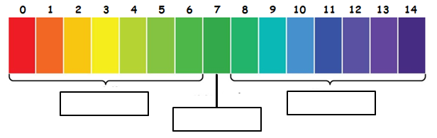

Use the pH scale below to answer the next three questions.

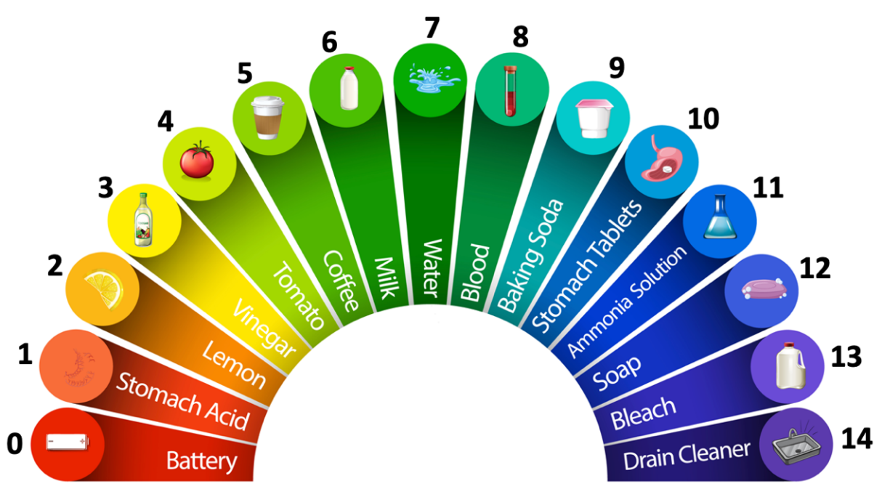

1. Which of the following is an **acid**?

|  |  |
| --- | --- |
| a) Lemon | b) Water |
| c) Ammonia Solution | d) Bleach |

1. Which of the following items would turn red litmus paper blue?

|  |  |
| --- | --- |
| a) Milk | b) Vinegar |
| c) Baking Soda | d) Tomato |

1. Which of the following would be considered the **strongest base**?

|  |  |
| --- | --- |
| a) Blood | b) Soap |
| c) Baking Soda | d) Drain Cleaner |

1. Which pH value indicates the **most acidic solution**?

|  |  |  |  |
| --- | --- | --- | --- |
| a) 7 | b) 2 | c) 5 | d) 11 |

1. Which of the following is a **base**?

|  |  |
| --- | --- |
| a) H2SO4 | b) HNO3 |
| c) HCl | d) NaOH |

1. Which of the following is an **acid**?

|  |  |
| --- | --- |
| a) Mg(OH)2 | b) Al(OH)3 |
| c) H2CO3 | d) NH4OH |

1. A solution with a pH of 8.0 is __________________.

|  |  |
| --- | --- |
| a) weakly acidic | b) strongly acidic |
| c) weakly basic | d) strongly basic |